**DHARSINH DESAI UNIVERSITY**



# FACULTY OF MANAGEMENT SCIENCE AND INFROMATION TECHNOLOGY

|  |  |
| --- | --- |
| **NAME** | **BHATT YAGNA** |
| ROLL NO | **MA006** |
| SUBJECT | **Web Development with Php** |
| PROJECT | **Ecommerce site** |

Contents

FACULTY OF MANAGEMENT SCIENCE AND INFROMATION TECHNOLOGY 1

2. Introduction 3

3. Overview Of the System Architecture 3

4. Components and Modules of YJAutohub 4

4.1 User Management Module: 4

4.2 Product Catalogue Module: 4

4.3 Shopping Cart Module: 4

4.4 Admin Module: 4

4.5 Filter Module: 4

4.6 Security Module: 4

5. User Roles and Permissions for YJAutohub 5

5.1 Guest/Unregistered User: 5

5.2 Registered User: 5

5.3 Administrator/Admin: 5

6. Features and Functionality 6

6.1 User Account Management: 6

6.2 Product Catalog and filter: 6

6.3 Shopping and Cart Management: 6

6.4 Admin Panel: 6

7. Technical Stack 7

7.1 Programming Language: 7

7.2 Web Framework: 7

7.3 Frontend Technologies: 7

7.4 Database Management System: 7

8. Code 8

8.1 Default.aspx 8

8.2 Sign in Page (c# code) 15

9. Screenshots 17

10. Conclusion 21

# Introduction

YJAutohub is an innovative and customer-centric e-commerce platform specializing in the online sale of automobiles, with a primary focus on cars. It is built using the C# programming language and the ASP.NET web framework, offering a seamless and secure shopping experience for car enthusiasts and buyers.

YJAutohub is committed to delivering a top-tier e-commerce experience for automotive enthusiasts of all kinds, providing a trusted marketplace for both buyers and sellers in the automobile industry. With its user-friendly interface, vast product selection that includes cars, bikes, and scooties, and a focus on security and reliability, YJAutohub aims to become a premier destination for those looking to buy vehicles online.

In addition to its wide range of products, YJAutohub also offers comprehensive customer support and after-sales services. This ensures that customers not only have a smooth buying experience but also receive necessary assistance after their purchase. The platform’s advanced search features allow users to find their desired vehicle based on various parameters like brand, model, price range, etc., making the shopping process more personalized and efficient. YJAutohub is not just about selling vehicles; it’s about creating a community of automobile enthusiasts and providing them with a platform that caters to all their needs.

# Overview Of the System Architecture

The overview of the system architecture for the "YJAutohub" e-commerce website should provide a high-level understanding of how the system is structured, the major components, and their interactions. Here's a sample overview:

1. **Web Server**: The web server hosts the application's back-end logic and serves as an intermediary between the client interface and the application's database. It handles user requests, processes them, and sends responses to the client.
2. **Application Layer**: This layer contains the core business logic of the system. It manages user authentication, product listings, shopping cart operations, payment processing, and order management. It ensures the security and integrity of user data.
3. **Database**: The database stores and manages all data related to users, products, orders, and other critical information. It is essential for data retrieval, storage, and maintenance. The system uses a [Database Management System] to efficiently manage and query data.
4. **External Services**: YJAutohub may integrate with external services for various purposes. These services could include payment gateways, shipping providers, and third-party APIs to enhance functionality and provide real-time data.
5. **Security Layer**: Security is a fundamental aspect of the architecture. It includes measures for user authentication and authorization, data encryption, and protection against common web security threats like SQL injection and cross-site scripting (XSS).
6. **Performance Optimization**: Performance optimization techniques are applied to ensure fast load times and a responsive user experience. Caching mechanisms and database optimization strategies are implemented to reduce latency.
7. **Scalability**: The architecture is designed to be scalable, allowing it to handle an increasing number of users and products. Load balancing and horizontal scaling are considered to ensure the system's performance remains optimal.

# Components and Modules of YJAutohub

In the context of the "YJAutohub" e-commerce website, components and modules refer to the various parts or building blocks of the system that work together to deliver specific functionalities. Moreover, having a modular architecture allows for better scalability as new features or improvements can be made to individual modules without impacting the entire system. This also aids in maintaining the system as issues can be isolated and resolved at the module level, reducing downtime and improving user experience. Below, I'll outline some of the key components and modules that you might consider in the system:

## User Management Module:

* + User Registration
  + User Authentication
  + User Profile Management

## Product Catalogue Module:

* + Product Listings
  + Search and Filter Functionality
  + Product Categories
  + Product Details Page

## Shopping Cart Module:

* + Add/Remove Products
  + Quantity Adjustment
  + Shopping Cart Summary
  + Save for Later

## Admin Module:

* + User Management (Admin)
  + Order Management (Admin)
  + Product management

## Filter Module:

* + Sorting Options
  + Vehicles based sorting

## Security Module:

* + User Authentication
  + Authorization and Access Control

# User Roles and Permissions for YJAutohub

Defining user roles and permissions is an important aspect of the "YJAutohub" e-commerce website, as it helps control access to different parts of the system and manage user privileges effectively. Here are some common user roles and their associated permissions for an e-commerce website:

In addition to these roles, it’s crucial to have a robust account management system. This includes features like password reset, two-factor authentication, and account recovery options. These features enhance the security of user accounts and protect against unauthorized access.

Furthermore, each user role should have a clear and intuitive user interface that caters to their specific needs. For example, an admin dashboard might include site analytics and user management tools, while a customer interface would focus on browsing products, managing their cart, and products.

Lastly, consider implementing a system for tracking user activity. This can help identify any unusual behaviour that might indicate a security threat, and it can also provide valuable insights into how users are interacting with the site.

## Guest/Unregistered User:

* + View Product Listings: Unregistered users can browse and view product listings.
  + Search and Filter Products: They can use search and filter options to find products.

## Registered User:

* + All Guest User Permissions: Registered users have the same permissions as guest users.
  + Register and Log In: They can create an account and log in to access additional features.
  + Save for Later: Registered users can save products for later purchase.
  + View User Profile: Access their user profile information.
  + Edit User Profile: Update their profile information, including contact details.

## Administrator/Admin:

* + All Buyer and Seller Permissions: Administrators have the same permissions as buyers and sellers.
  + User Management: Create, edit, and delete user accounts.
  + Product Management: Manage all product listings on the platform.
  + Order Management: Access and manage all orders, including processing refunds, handling disputes, and modifying orders if necessary.
  + Site Configuration: Modify website settings and configurations.
  + Security Management: Oversee security settings and permissions.
  + Compliance and Legal: Ensure the platform comply with legal and regulatory requirements.

# Features and Functionality

The features and functionality of the "YJAutohub" e-commerce website play a pivotal role in delivering a seamless and satisfying user experience. Below is a list of essential features and functionalities that an automobile e-commerce website like YJAutohub should consider:

addition to these, it’s important to have a robust search and filter functionality. This allows users to easily find the vehicles they’re interested in based on various parameters such as brand, model, price range, etc. An advanced search feature can significantly enhance the user experience by making the product discovery process more efficient and personalized.

Moreover, integrating a comparison feature could be highly beneficial. This feature would allow users to compare different vehicles side-by-side based on various attributes like price, features, specifications, etc. It can help users make more informed decisions and enhance their shopping experience on the platform.

## User Account Management:

* **User Registration:** Allow users to create accounts with their personal information.
* **User Authentication:** Implement secure login mechanisms with username and password or other authentication methods like OAuth.
* **User Profile Management:** Enable users to update their personal information, contact details, and preferences.

## Product Catalog and filter:

* **Extensive Product Listings:** Showcase a wide range of car makes, models, and variations in the Catalog.
* **Filter Options:** Provide robust search and filtering capabilities to help users find the exact car they desire based on criteria like price range, make, model, year, and more.
* **Product Details:** Display detailed information about each product, including images, specifications, pricing, seller details, and reviews.

## Shopping and Cart Management:

* **Add to Cart:** Allow users to add products to their shopping cart.
* **Shopping Cart Management:** Enable users to view and modify the items in their shopping cart, including adjusting quantities and removing items.
* **Save for Later:** Provide an option to save products for future consideration.

## Admin Panel:

* **Product Management:** Offer sellers and administrators the ability to add, edit, and delete product listings.
* **Order Management:** Provide an interface for managing orders, tracking order fulfilment, and handling customer inquiries.
* **Sales Analytics:** Give sellers access to sales reports and analytics related to their products.
* **User Management:** Allow administrators to create, edit, and delete user accounts and manage user permissions.

# Technical Stack

The technical stack for the “YJAutohub” e-commerce website, built in C#, is a comprehensive collection of technologies and tools that work together to support its development and operation. This stack is carefully chosen to ensure that every aspect of the website, from the user interface to the backend logic, works seamlessly and efficiently.

The choice of C# as the primary programming language provides a strong, type-safe, and object-oriented foundation for the application. It allows for clean, maintainable code that can be easily understood and modified by different developers.

The web framework, database management system, and frontend technologies are all integral parts of this stack. They each play a crucial role in delivering a high-quality, user-friendly e-commerce experience. The web framework handles the server-side logic and routes user requests to the appropriate handlers. The database management system stores and retrieves data efficiently, ensuring that users can view and purchase products without delay. The frontend technologies make sure that the website looks good and functions well on a variety of devices.

In addition to these core components, various other tools and libraries are used to enhance the website’s functionality and performance. These may include testing frameworks for ensuring code quality, security libraries for protecting user data, and deployment tools for managing the website’s release process.

Overall, the technical stack is a vital part of the “YJAutohub” e-commerce website. It’s not just about choosing the right technologies; it’s also about how these technologies are used together to create a cohesive, robust, and scalable system.

## Programming Language:

* + **C#**: The primary language for server-side logic and application development.

## Web Framework:

* + **ASP.NET**: Utilize the ASP.NET framework to build the web application, which includes the ASP.NET MVC framework for developing web applications.

## Frontend Technologies:

* + **HTML5**: The markup language for creating the structure of web pages.
  + **CSS3**: Cascading Style Sheets for web page styling and layout.
  + **JavaScript**: For client-side scripting and interactivity.
  + **jQuery**: Enhance client-side functionality and user interactions, including AJAX for registration and login.

## Database Management System:

* + **Microsoft SQL Server**: A robust and scalable relational database management system (RDBMS) to store and manage product data, user data, and order information.
  + Create a "user" table in the database to store user registration and login information. This table should include fields like username, password (hashed and salted), email, and any other user-related data.

# Code

## Default.aspx

<%@ Page Language="C#" AutoEventWireup="true" CodeBehind="Default.aspx.cs" Inherits="YJ_AUTOHUB.Default" %>

<!DOCTYPE html>

<html xmlns="http://www.w3.org/1999/xhtml">

<head runat="server">

<title>YJ AUTOHUB</title>

<link rel="stylesheet" href="https://maxcdn.bootstrapcdn.com/bootstrap/3.4.1/css/bootstrap.min.css" />

<script src="https://ajax.googleapis.com/ajax/libs/jquery/3.5.1/jquery.min.js"></script>

<script src="https://maxcdn.bootstrapcdn.com/bootstrap/3.4.1/js/bootstrap.min.js"></script>

</head>

<body>

<form id="form1" runat="server">

<div>

<div class="jumbotron text-center" style="margin-bottom: 0">

<h1>YJ AUTOHUB</h1>

<p>Your Ultimate Destination for Cars, Bikes, and Scooters</p>

</div>

<nav class="navbar navbar-default navbar-fixed-top">

<div class="container">

<div class="navbar-header">

<button type="button" class="navbar-toggle" data-toggle="collapse" data-target=“. navbar-collapse">

<span class="sr-only">Toggle navigation</span>

<span class="icon-bar"></span>

<span class="icon-bar"></span>

<span class="icon-bar"></span>

</button>

<a class="navbar-brand" href="Default.aspx">

<img src="icons/safeIcons.png" alt="#" height="30" />

YJ Aut Hub

</a>

</div>

<div class="navbar-collapse collapse">

<ul class="nav navbar-nav navbar-right">

<li class="active">

<asp:LinkButton ID="lnkHome" runat="server" Text="Home" PostBackUrl="~/Default.aspx"></asp:LinkButton>

</li>

<li>

<asp:LinkButton ID="lnkAbout" runat="server" Text="About" PostBackUrl="~/About.aspx"></asp:LinkButton>

</li>

<li>

<asp:LinkButton ID="lnkProducts" runat="server" Text="Products" PostBackUrl="~/Products.aspx"></asp:LinkButton>

</li>

<li>

<asp:LinkButton ID="lnkCart" runat="server" Text="Cart" PostBackUrl="~/Cart.aspx"></asp:LinkButton>

</li>

<li>

<asp:LinkButton ID="lnkSignIn" runat="server" Text="Sign In" PostBackUrl="~/signin.aspx"></asp:LinkButton>

</li>

</ul>

</div>

</div>

</nav>

<div class="container">

<h2>Explore Our Featured Vehicles</h2>

<div id="myCarousel" class="carousel slide" data-ride="carousel">

<ol class="carousel-indicators">

<li data-target="#myCarousel" data-slide-to="0" class="active"></li>

<li data-target="#myCarousel" data-slide-to="1"></li>

<li data-target="#myCarousel" data-slide-to="2"></li>

</ol>

<div class="carousel-inner">

<div class="item active">

<asp:Image ID="imgCar1" runat="server" ImageUrl="ImgSlider/car1.jpg" AlternateText="Car 1" CssClass="img-responsive" />

<div class="carousel-caption">

<h3>Stylish Cars</h3>

<p>Experience luxury and performance with our top-of-the-line car collection.</p>

<asp:HyperLink ID="lnkViewCars" runat="server" CssClass="btn btn-lg btn-primary" NavigateUrl="Products.aspx" Text="View Cars"></asp:HyperLink>

</div>

</div>

<div class="item">

<asp:Image ID="imgCar2" runat="server" ImageUrl="ImgSlider/car2.jpg" AlternateText="Car 2" CssClass="img-responsive" />

<div class="carousel-caption">

<h3>Thrilling Cars</h3>

<p>Discover adventure with our powerful and dynamic car selection.</p>

<asp:HyperLink ID="lnkViewBikes" runat="server" CssClass="btn btn-lg btn-primary" NavigateUrl="Products.aspx" Text="View Vehicle"></asp:HyperLink>

</div>

</div>

<div class="item">

<asp:Image ID="imgScooter1" runat="server" ImageUrl="ImgSlider/car3.jpg" AlternateText="Scooter 1" CssClass="img-responsive" />

<div class="carousel-caption">

<h3>Super cars</h3>

<p>Experience urban mobility with our range of comfortable and efficient scooters. </p>

<asp:HyperLink ID="lnkViewScooters" runat="server" CssClass="btn btn-lg btn-primary" NavigateUrl="Products.aspx" Text="Premium car"></asp:HyperLink>

</div>

</div>

</div>

<a class="left carousel-control" href="#myCarousel" data-slide="prev"><span class="glyphicon glyphicon-chevron-left"></span><span class="sr-only">Previous</span></a>

<a class="right carousel-control" href="#myCarousel" data-slide="next"><span class="glyphicon glyphicon-chevron-right"></span><span class="sr-only">Next</span></a>

</div>

</div>

<div class="container center">

<hr. />

<div class="row">

<div class="col-lg-4">

<asp:Image ID="imgCars" runat="server" ImageUrl="Images/car1.jpg" AlternateText="Cars" CssClass="img-circle" Width="140" Height="140" />

<h2>Cars</h2>

<p>Explore a wide range of stylish and powerful cars at YJ Auto Hub. Our collection includes the latest models from top brands with advanced features and unmatched performance. </p>

<p><a class="btn btn-default" href="#" role="button">View More &raquo;</a></p>

</div>

<div class="col-lg-4">

<asp:Image ID="imgBikes" runat="server" ImageUrl="Images/bike4.jpg" AlternateText="Bikes" CssClass="img-circle" Width="140" Height="140" />

<h2>Bikes</h2>

<p>Discover thrilling biking experiences with our selection of high-performance bikes. From sporty models to cruisers, YJ Auto Hub has the perfect ride for every adventure. </p>

<p><a class="btn btn-default" href="#" role="button">View More &raquo;</a></p>

</div>

<div class="col-lg-4">

<asp:Image ID="imgScooters" runat="server" ImageUrl="Images/scooty1.jpg" AlternateText="Scooters" CssClass="img-circle" Width="140" Height="140" />

<h2>Scotty</h2>

<p>Experience convenience and style with our collection of efficient and comfortable scooters. YJ Auto Hub offers a range of options for urban commuting and leisure rides.</p>

<p><a class="btn btn-default" href="#" role="button">View More &raquo;</a></p>

</div>

</div>

<div class="panel panel-primary">

<div class="panel-heading">

SPECIAL DIWALI SELL

</div>

<div class="panel-body">

<div class="row" style="padding-top: 50px">

<div class="row">

<div class="col-sm-3 col-md-3">

<a href='Products.aspx' style="text-decoration: none;">

<div class="custom-box product-item">

<img src="Images/bike2.jpg" alt="Product 2" />

<div class="caption">

<div class="probrand">

Hero

</div>

<div class="proName">

Spelndor Super

</div>

<div class="proPrice">

<span class="proOgPrice"> ₹100000.00

</span>

₹80000.00

<span class="proPriceDiscount">(20%.00 off)</span>

</div>

</div>

</div>

</a>

</div>

<div class="col-sm-3 col-md-3">

<a href='Products.aspx' style="text-decoration: none;">

<div class="custom-box product-item">

<img src="Images/car2.jpg" alt="Product 2" />

<div class="caption">

<div class="probrand">

Mahindra

</div>

<div class="proName">

Thar

</div>

<div class="proPrice">

<span class="proOgPrice"> ₹1500000.00

</span>

₹12,00,000.00

<span class="proPriceDiscount">(20%.00 off)</span>

</div>

</div>

</div>

</a>

</div>

<div class="col-sm-3 col-md-3">

<a href='Products.aspx' style="text-decoration: none;">

<div class="custom-box product-item">

<img src="Images/car3.jpg" alt="Product 2" />

<div class="caption">

<div class="probrand">

Tata

</div>

<div class="proName">

Tata safari

</div>

<div class="proPrice">

<span class="proOgPrice"> ₹2000000.00

</span>

₹18,00,000.00

<span class="proPriceDiscount">(10%.00 off)</span>

</div>

</div>

</div>

</a>

</div>

</div>

</div>

</div>

<div class="panel-footer">

Buy 2 vehicles and get a special offer

</div>

</div>

</div>

<footer style="background-color: #333; color: white;">

<div class="container">

<div class="row">

<div class="col-md-4">

<h4>About Us</h4>

<p>We are your ultimate destination for cars, bikes, and scooters. Explore our premium collection and experience luxury and adventure like never before. </p>

</div>

<div class="col-md-4">

<h4>Quick Links</h4>

<ul class="list-unstyled">

<li><a href="Default.aspx">Home</a></li>

<li><a href="About.aspx">About</a></li>

<li><a href="#">Contact</a></li>

<li><a href="Products.aspx">Products</a></li>

</ul>

</div>

<div class="col-md-4">

<h4>Connect with Us</h4>

<ul class="list-unstyled">

<li><a href="#"><i class="fa fa-facebook"></i>Facebook</a></li>

<li><a href="#"><i class="fa fa-twitter"></i>Twitter</a></li>

<li><a href="#"><i class="fa fa-instagram"></i>Instagram</a></li>

</ul>

</div>

</div>

<hr style="border-color: #777;" />

<p class="text-center">&copy;<%= DateTime.Now.Year %> YJ AutoHub.in. All rights reserved. </p>

</div>

</footer>

</div>

</form>

<script src="https://ajax.googleapis.com/ajax/libs/jquery/3.5.1/jquery.min.js"></script>

<script src="https://maxcdn.bootstrapcdn.com/bootstrap/3.4.1/js/bootstrap.min.js"></script>

</body>

</html>

## Sign in Page (c# code)

using System;

using System.Data.SqlClient;

using System.Web.UI;

namespace YJ_AUTOHUB

{

public partial class Sign in : Page

{

SqlConnection con;

readonly string connectionString = @"Data Source=(LocalDB)\MSSQLLocalDB;AttachDbFilename=C:\Users\iamja\OneDrive\Documents\Autohub.mdf;Integrated Security=True;Connect Timeout=30";

protected void Page_Load(object sender, EventArgs e)

{

}

protected void btnLogin_Click(object sender, EventArgs e)

{

string userEmail = txtLoginEmail.Text.Trim();

string query = "SELECT Password FROM [User] WHERE Email = @userEmail";

try

{

using (con = new SqlConnection(connectionString))

{

con.Open();

using (SqlCommand command = new SqlCommand(query, con))

{

command.Parameters.AddWithValue("@userEmail", userEmail);

using (SqlDataReader reader = command.ExecuteReader())

{

if (reader.Read())

{

string storedPasswordHash = reader["Password"].ToString();

string enteredPassword = txtLoginPassword.Text.Trim();

if (enteredPassword == storedPasswordHash) //

Session["User"] = userEmail;

Response.Write("<script>alert('Login success')</script>");

Response.Redirect("~/Default.aspx");

}

else

{

Response.Write("<script>alert('Invalid credentials')</script>");

}

}

else

{

Response.Write("<script>alert('User not found')</script>");

}

}

}

}

}

catch (Exception ex)

{

Response.Write("<script>alert('" + ex.Message + "')</script>");

}

}

protected void btnRegister_Click(object sender, EventArgs e)

{

Response.Redirect("~/Register.aspx");

}

}

}

# Screenshots

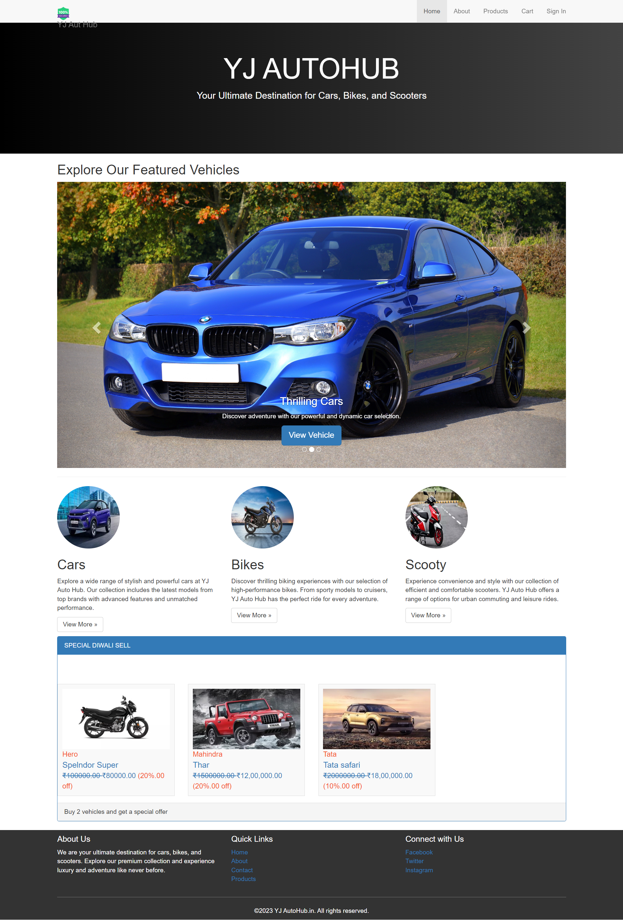

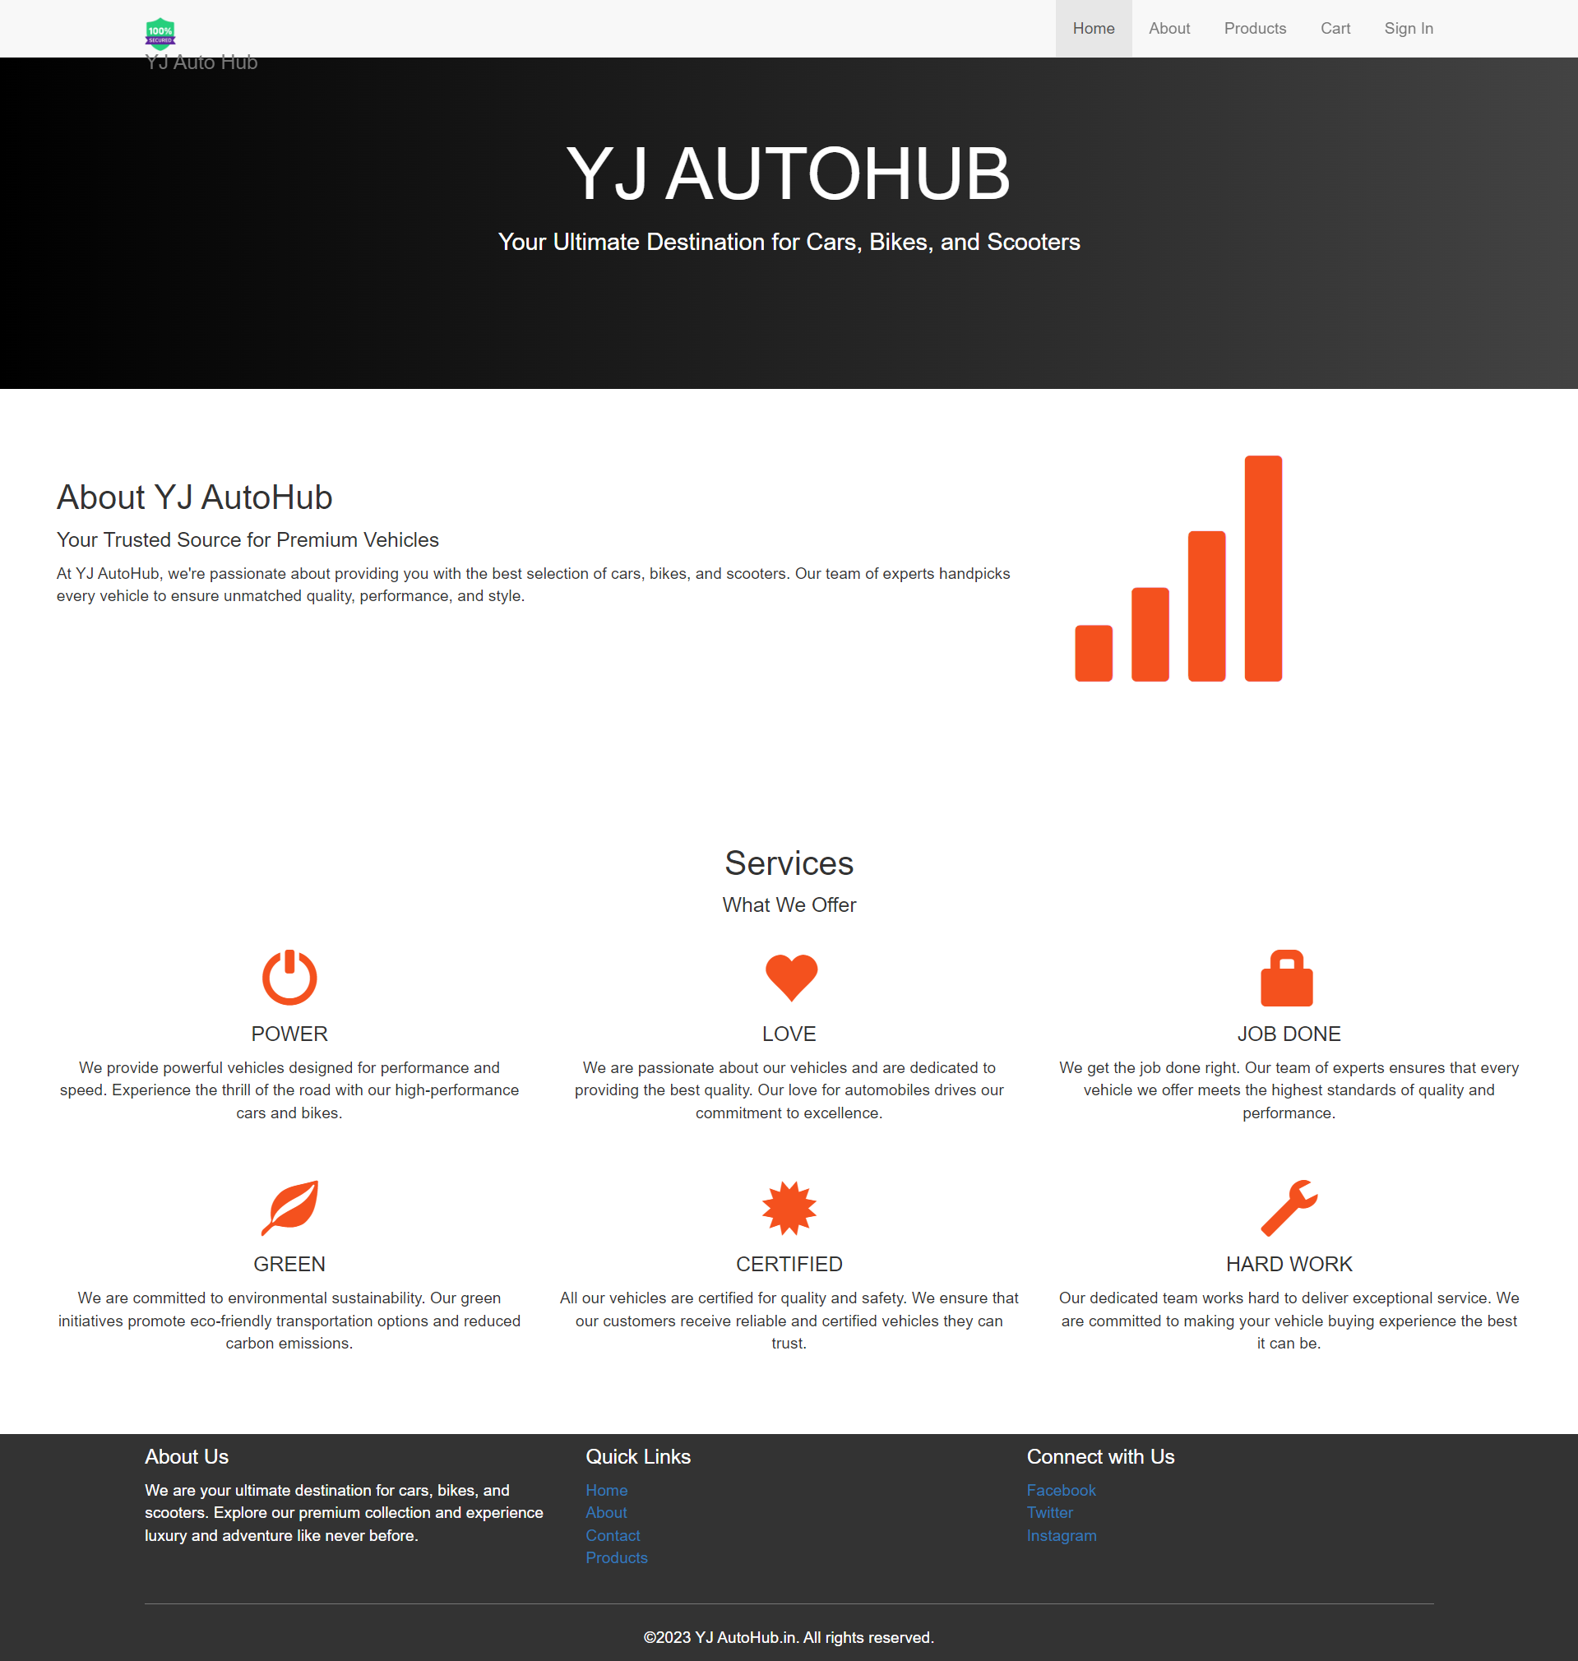

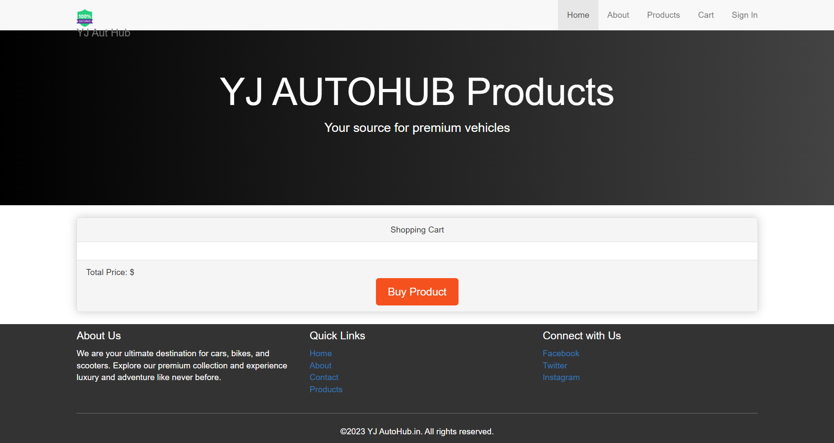

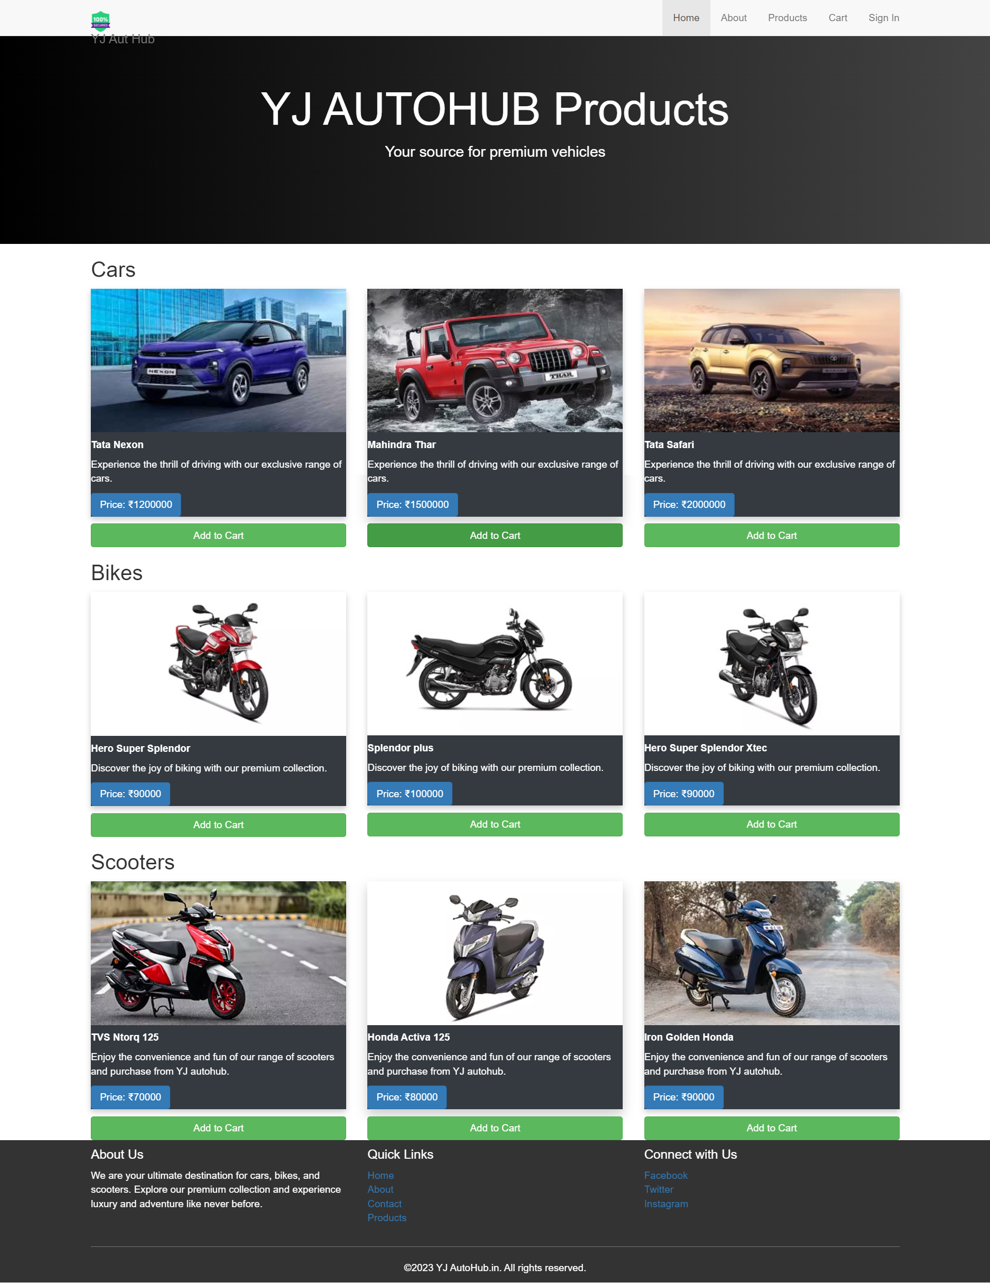

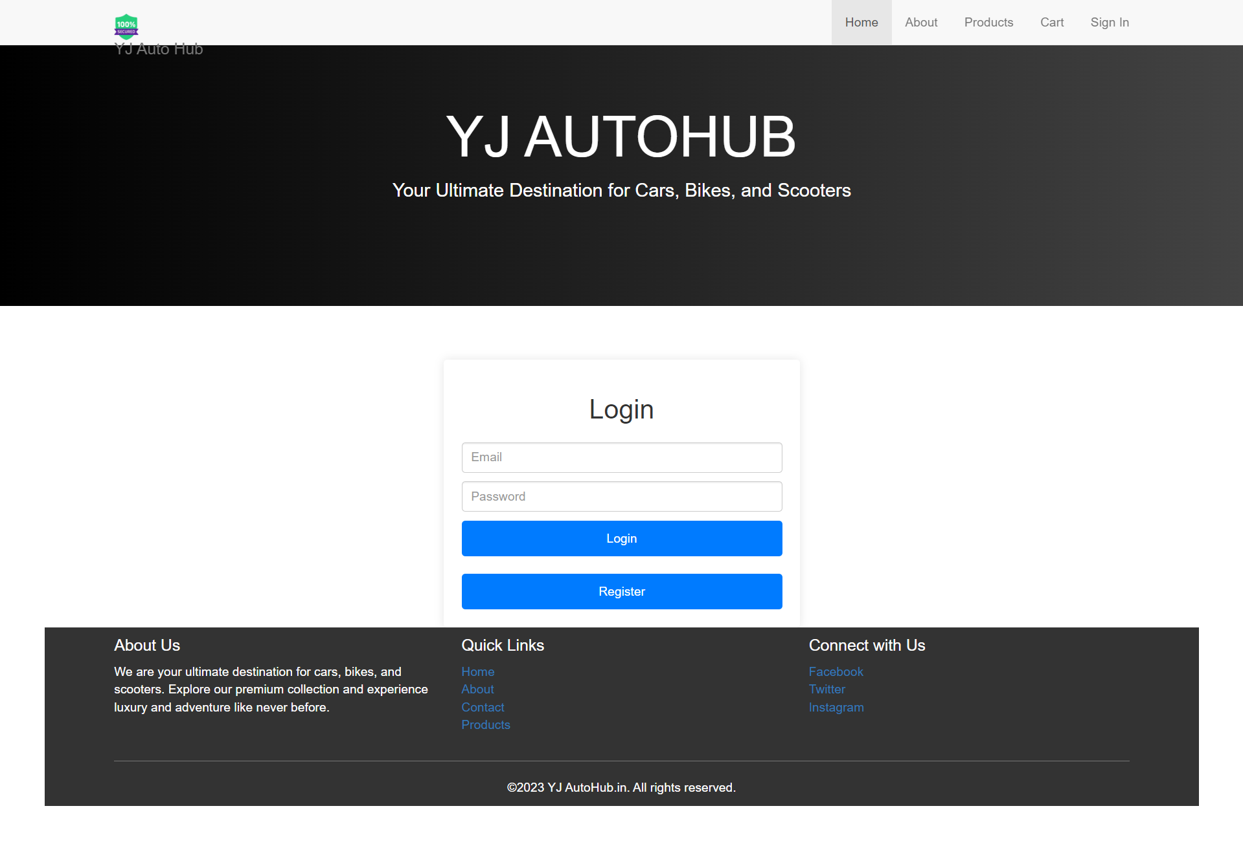

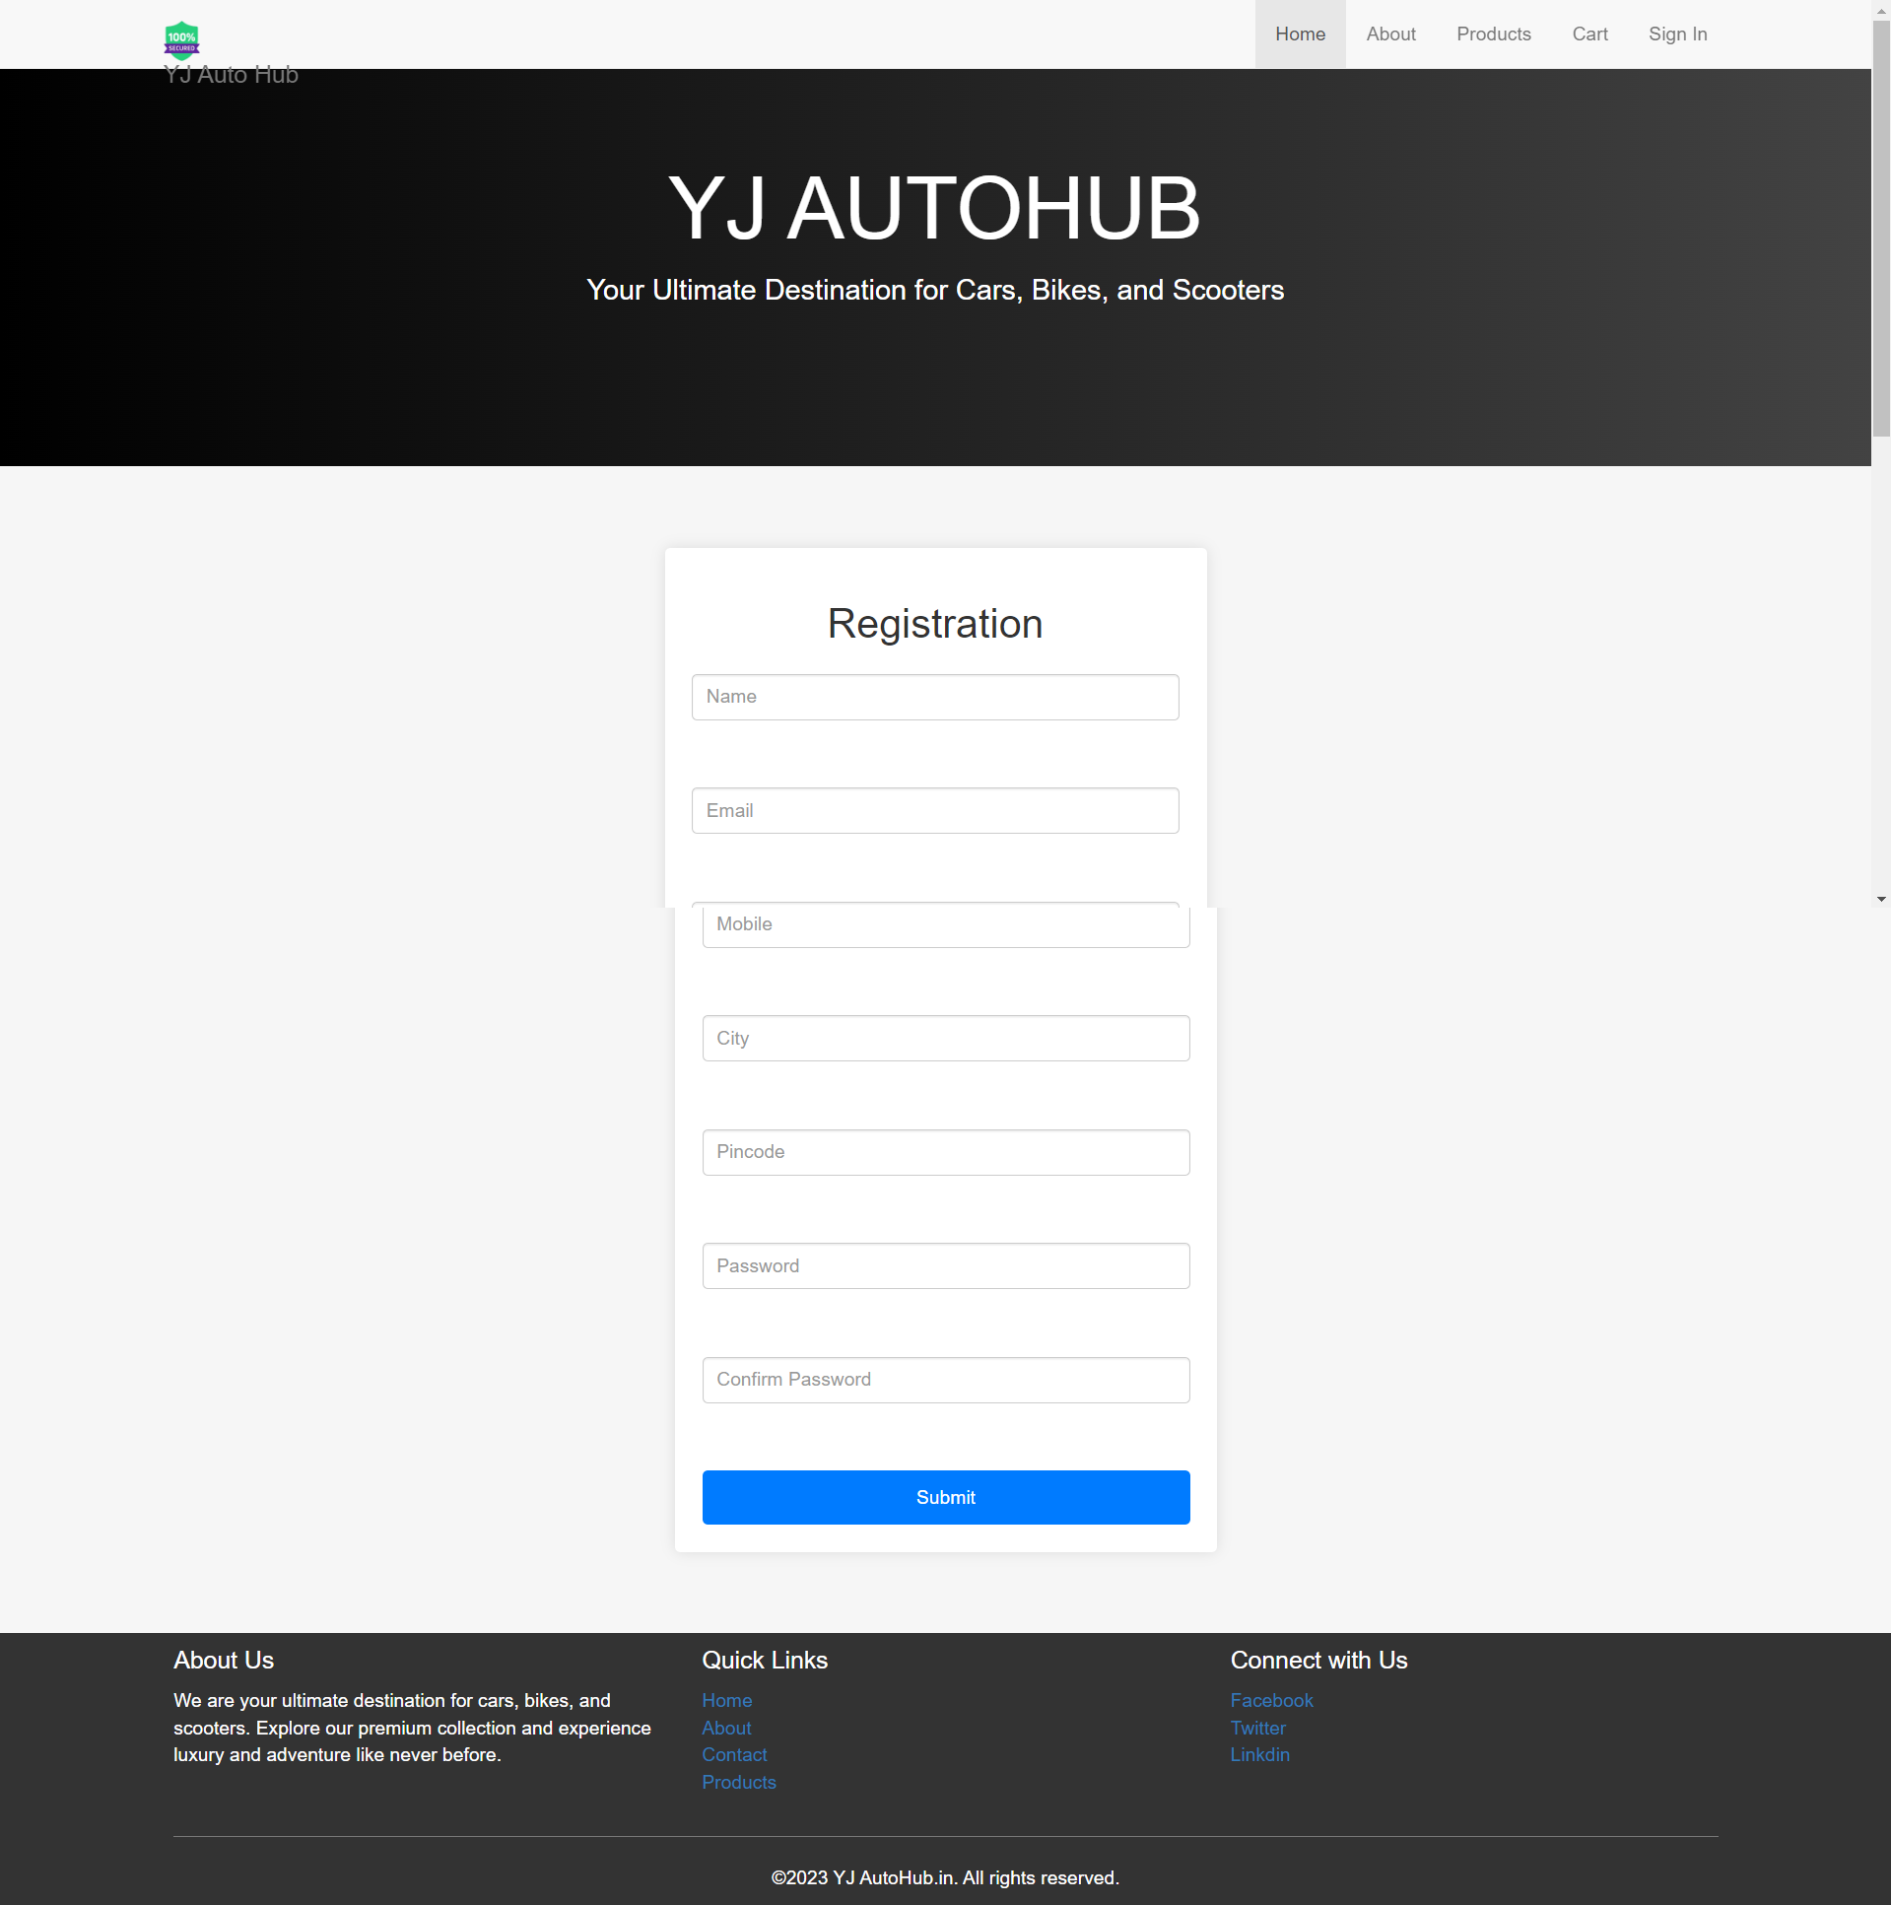

# Conclusion

In conclusion, the journey of developing the “YJAutohub” e-commerce website has been a thrilling and rewarding adventure. Our vision was to create a comprehensive and seamless online platform for the sale of various vehicles, including cars, bikes, and shooties. This endeavour required us to delve into numerous technical and design aspects, from architecting a robust system to defining precise user roles and permissions, implementing a diverse set of features and functionalities, and designing an intuitive and aesthetically pleasing user interface.

Our heartfelt gratitude goes out to our dedicated team, supportive stakeholders, and valued users who have made this project a reality. Their unwavering commitment and constructive feedback have been instrumental in shaping “YJAutohub” into the platform it is today.

We invite you to embark on this exciting journey with us by exploring “YJAutohub”. As we continue to evolve and expand our offerings, we look forward to your continued patronage and invaluable feedback. We are committed to making “YJAutohub” your go-to destination for online vehicle shopping, providing you with a trusted marketplace that caters to all your automotive needs.